Graphing Quadratics With
Horizontal & Vertical Translations

Do all work on a separate piece of graph paper. (MAX two parabolas per grid)

Explain how the graphs of each pair of functions are related. Graph the second function in each pair, and determine its vertex, axis of symmetry, domain, range, and maximum or minimum value.
1) $y=x^{2} \text{and} y={(x-6)}^{2}$
2) $y=x^{2} \text{and} y={(x+1)}^{2}$
3) $y=x^{2} \text{and} y={(x+4)}^{2}+3$
4) $y=x^{2} \text{and} y={(x-2)}^{2}-1$
5) $y=x^{2} \text{and} y=x^{2}+3$
6) $y=x^{2} \text{and} y={(x+2)}^{2}-4$
7) $y=x^{2} \text{and} y=x^{2}-1$
8) $y=x^{2} \text{and} y={(x-2)}^{2}$
9) $y=x^{2} \text{and} y={(x+5)}^{2}+2$
10) $y=x^{2} \text{and} y={\left(x-3\right)}^{2}-3$

KEY (continued on back)
- translation 6 units right
- translation 1 unit left
- translation 4 units left & 3 units up
- translation 2 units right & 1 unit down
- translation 3 units up
- translation 2 units left & 4 units down
- translation 1 unit down
- translation 2 units right
- translation 5 units left & 2 units up
- translation 3 units right & 3 units down
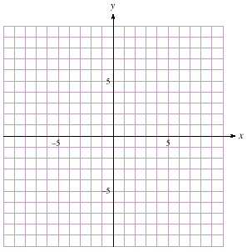
KEY
1) $(6, 0)$ 3) $(-4, 3)$
$x=6$ $x=-4$
$R$ $R$
$y≥0$ $y≥3$
min $0$ min $3$

2) $(-1, 0)$ 4) $(2, -1)$
$x=-1$ $x=2$
$R$ $R$
$y≥0$ $y≥-1$
min $0$ min $-1$

5) $(0, 3)$ 7) $(0, -1)$
$x=0$ $x=0$
$R$ $R$
$y≥3$ $y≥-1$
min $3$ min $-1$

6) $(-2, -4)$ 8) $(2, 0)$
$x=-2$ $x=2$
$R$ $R$
$y≥-4$ $y≥0$
min $-4$ min $0$

9) $(-5, 2)$
$x=-5$
$R$
$y≥2$
min $2$

10) $(3, -3)$
$x=3$
$R$
$y≥-3$
min $-3$

