Unit 3: Quadratic Functions
3.1A Quadratic Functions in Vertex Form I

Quadratic Function:

Parabola:

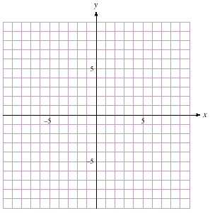
ex. Complete the table of values and graph $y=x^{2}$
$$x$$ | $$y$$
-3
-2
-1
0
1
2
3

Vertex:

Minimum/Maximum Value:

Axis of Symmetry:

Vertex Form of a Quadratic Function:

Translation:

Vertical Translations: $y=x^{2}+q$ or $f(x)=x^{2}+q$

ex. Sketch:
- $y=x^{2}+3$

- $f(x)=x^{2}-4$

Horizontal Translations: $y={\left(x-p\right)}^{2}$ or $f(x)={\left(x-p\right)}^{2}$

ex. Sketch:
- $f(x)={\left(x-5\right)}^{2}$

- $y={\left(x+2\right)}^{2}$

Combinations: $y={\left(x-p\right)}^{2}+q$ or $f(x)={\left(x-p\right)}^{2}+q$

ex. Complete without graphing, then sketch:

- $f(x)={(x-1)}^{2}-5$
- $y={(x+3)}^{2}+1$

Vertex:

Axis of Symmetry:

Domain:

Range:

Max/Min:

Vertex:

Axis of Symmetry:

Domain:

Range:

Max/Min:

Practice: pg. 157 / #2
& WS3.1A
Unit 3: Quadratic Functions
3.1B Quadratic Functions in Vertex Form II

Vertical Stretches (Expansions/Compressions) & Reflections: $y=ax^{2}$ or $f\left(x\right)=ax^{2}$

ex. Sketch:
a) $y=2x^{2}$ b) $f\left(x\right)=-\frac{1}{2}x^{2}$ c) $f\left(x\right)=\frac{1}{4}{\left(x-3\right)}^{2}-2$ d) $y=-3{\left(x+1\right)}^{2}+10$

ex. Write the equation in vertex form of each parabola graphed below.
- b)

ex. A parabola has vertex (6 , -5) and passes through the point (2 , -9). Determine its equation in vertex form.

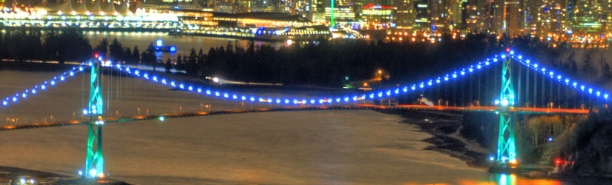
ex. The deck of the Lions’ Gate Bridge in Vancouver is suspended from two main cables attached to the tops of two supporting towers. Between the towers, the main cables take the shape of a parabola as they support the weight of the deck. The towers are 111 m tall relative to the water’s surface and are 472 m apart. The lowest point of the cables is approximately 67 m above the water’s surface.
- Model the shape of the cables with a quadratic function in vertex form.

- Determine the height above the surface of the water of a point on the cables that is 90 m horizontally from one of the towers. Express your answer to the nearest hundredth of a meter.

Practice: pg. 157/ #
Consider the vertex form quadratic $f\left(x\right)=3{\left(x+2\right)}^{2}-4$.
State the values of $a, p \& q$

Expand $f\left(x\right)=3{\left(x+2\right)}^{2}-4$ into standard form.

State the values of $a, b \& c$

How do the values of $a, p \& q$ compare to the values of $a, b \& c$?

Expand $f\left(x\right)=a{\left(x-p\right)}^{2}+q$ into standard form.

Express $p \& q$ in terms of $a, b \& c$?
Unit 3: Quadratic Functions
3.2 Quadratic Functions in Standard Form

Vertex form quadratic: $f\left(x\right)=a{\left(x-p\right)}^{2}+q$where $a,p,q∈R;a≠0$
Standard form quadratic: $f(x)=ax^{2}+bx+c$ where $a,b,c∈R;a≠0$
- a determines the _______________________________________________________________

& influences the ________________________________________________________________

- b influences ____________________________________________________________________

- c represents ___________________________________________________________________

& influences the ________________________________________________________________

ex. graph the parabola $f\left(x\right)=2x^{2}-3x-5$ on a calculator and state:

- vertex

- axis of Symmetry

- direction of opening

- $y$-intercept

- $x$-intercepts

- domain

- range

ex. graph the parabola $f\left(x\right)=-\frac{1}{2}x^{2}-5x+10$ on a calculator and state:

- vertex

- axis of Symmetry

- direction of opening

- $y$-intercept

- $x$-intercepts

- domain

- range

ex. A frog sitting on a rock jumps into a pond. The height, h, in centimeters of the frog above the surface of the water as a function of time, t, in seconds, since it jumped can be modeled by the function $h(t)=-490t^{2}+150t+25$. Where appropriate, answer the following questions to the nearest tenth.
- Graph the function, sketch.

- What is the y-intercept? What does it represent in this situation?

- What maximum height does the frog reach? When does it reach that height?

- When does the frog hit the surface of the water?

- What are the domain and range in this situation?

- How high is the frog 0.25 seconds after it jumps?

ex. A rancher has 100 m of fencing available to build a rectangular corral. Answer the following questions without the aid of the graphing features of a graphing calculator.
- Write a quadratic function in standard form to represent the area of the corral.

- What are the coordinates of the vertex? What does the vertex represent in this situation?

- Sketch the graph for the function you found in a).

- Determine the domain and range.

- Identify any assumptions you made in modeling this situation mathematically.

Practice: pg. 174/ #
Unit 3: Quadratic Functions
3.3 Completing the Square
We convert a quadratic function from standard form $f(x)=ax^{2}+bx+c$ to vertex form
$f\left(x\right)=a{\left(x-p\right)}^{2}+q$ using a process called completing the square

ex. Convert to vertex form: $y=x^{2}+8x+10$
*recall algebra tile method & replicate algebraically
Step Algebra tiles Algebraic

1) Lay out trinomial
- separate constant

2) complete the square
- balance out the added
values

3) factor the perfect square
- combine constants

ex. convert each quadratic to vertex form:
$f\left(x\right)=x^{2}-2x+3$ $y=x^{2}+3x+1$

When completing the square, we must factor out leading coefficients $≠1$ from the $x$ terms.
Be careful with balancing the completion of the square!
ex. convert each quadratic to vertex form:
$y=3x^{2}-12x+6$ $f\left(x\right)=-x^{2}+10x-20$

$f\left(x\right)=-4x^{2}-20x+1$ $y=2x^{2}+7x$

ex. The leadership class is planning a fundraising with a professional photographer taking portraits of individuals or groups. The class gets to charge and keep a session fee for each individual or group photo sessions. Last year, they charged a $10 session fee and 400 sessions were booked. In considering what price they should charge this year, the class estimates that for every $1 increase in the price, they expect to have 20 fewer sessions booked.
- Write a function to model this situation.

- What is the maximum revenue they can expect based on these estimates? What session fee will give that maximum?

- How can you verify the solution?

Practice: pg. 192/#
Note: = + (positive red tiles) = - (negative blue tiles)

Part I Use algebra tiles to determine each binomial square. Sketch the results.

${\left(x+2\right)}^{2}=$ ${\left(x-4\right)}^{2}=$

What shape do all the tiles as a whole make in the solution layout?
Describe the solution layout as four quadrants?

Are the square quadrants always positive or negative?
Part II Use algebra tiles to explain why each trinomial is NOT a perfect square. Sketch the results.

$x^{2}+6x+10$ $x^{2}+6x-9$ $x^{2}-7x+9$

Part III For each non-perfect square trinomial add-on extra zero pairs to “complete the square”. Then factor the square and write each trinomial as a binomial square plus a constant. Sketch the results.
$x^{2}-10x$ $x^{2}+8x+3$ (*pull the constant to the side)

$x^{2}-4x+5$ $x^{2}+6x-7$

PART IV Fill in the blanks to make each equation true.
1. (x² + 10x + _____) = (x + 5)² | 2. (x² - 14x + _____) = (x - 7)²
3. (x² – 12x _____) = (x______)² | 4. (x² - 18x _____) = (x ______)²
5. (x² + 100x _____) = (x ______)² | 6. (x² + 5x _____) = (x _______)²
7. (x² - 11x _____) = (x _______)² | 8. (x² + $\frac{3}{4}$x _____) = (x ______)²

